Java FSE – Hands on Assignment

Name: Angarag Seal
Email: angaragseal55@gmail.com
Week -2

Exercise 1: Configuring a Basic Spring Application
Scenario:
Your company is developing a web application for managing a library. You need to use the Spring Framework to handle the backend operations.
Steps:
- Set Up a Spring Project:
  - Create a Maven project named LibraryManagement.
  - Add Spring Core dependencies in the pom.xml file.
- Configure the Application Context:
  - Create an XML configuration file named applicationContext.xml in the src/main/resources directory.
  - Define beans for BookService and BookRepository in the XML file.
- Define Service and Repository Classes:
  - Create a package com.library.service and add a class BookService.
  - Create a package com.library.repository and add a class BookRepository.
- Run the Application:
  - Create a main class to load the Spring context and test the configuration.
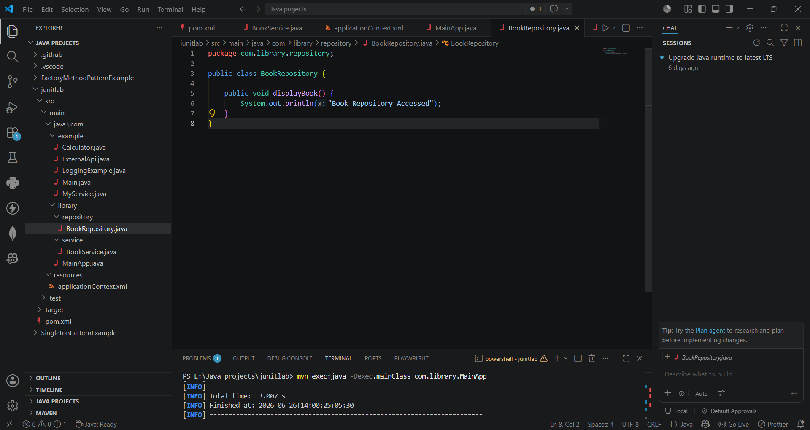
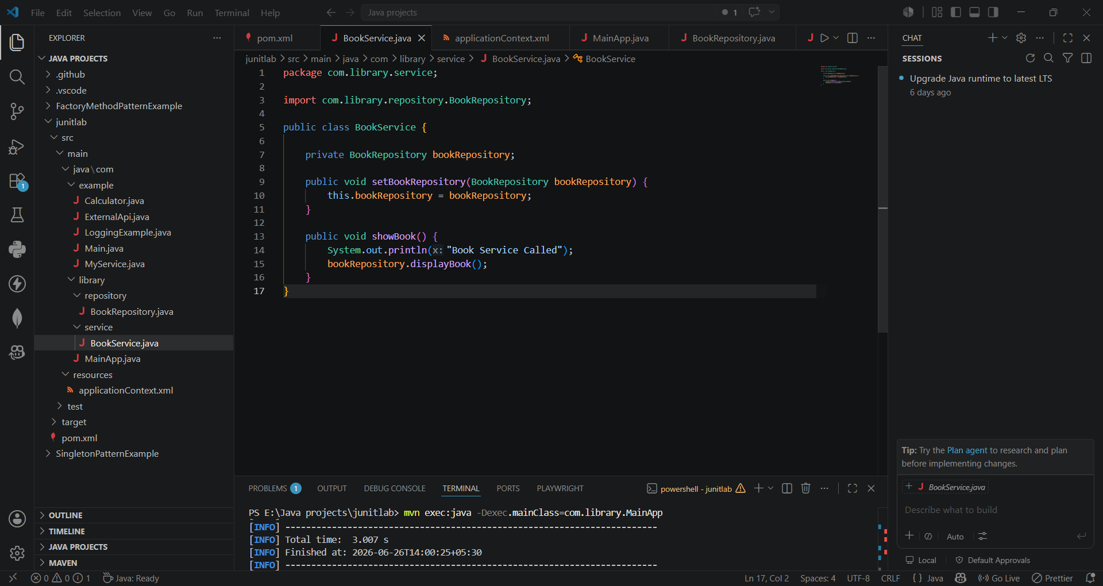
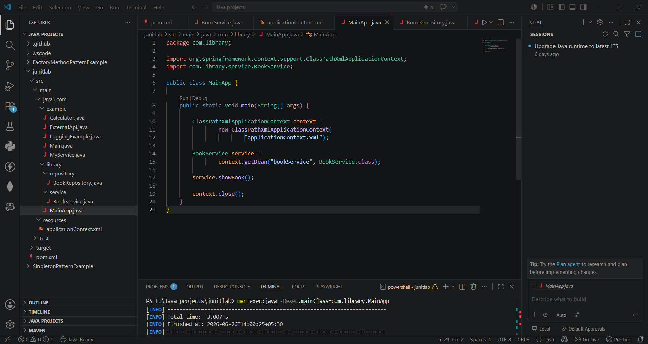
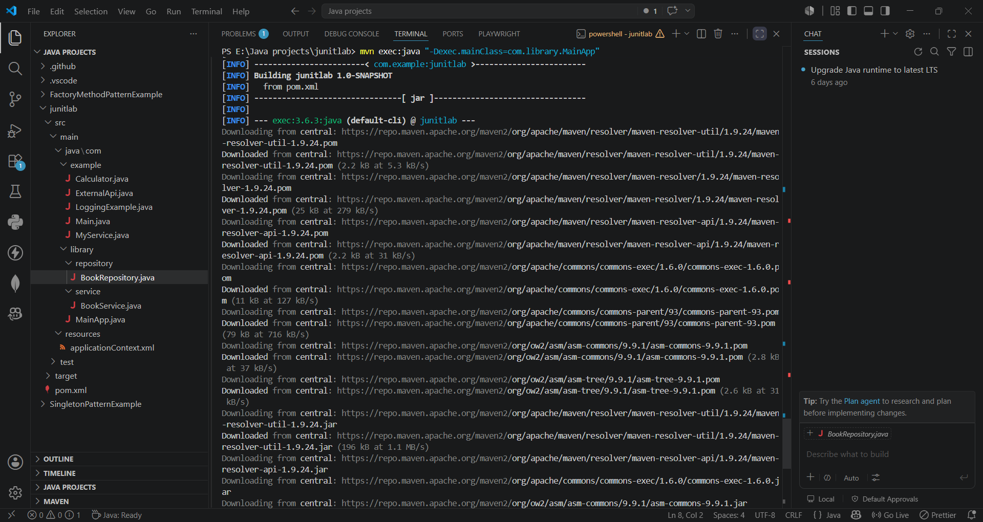
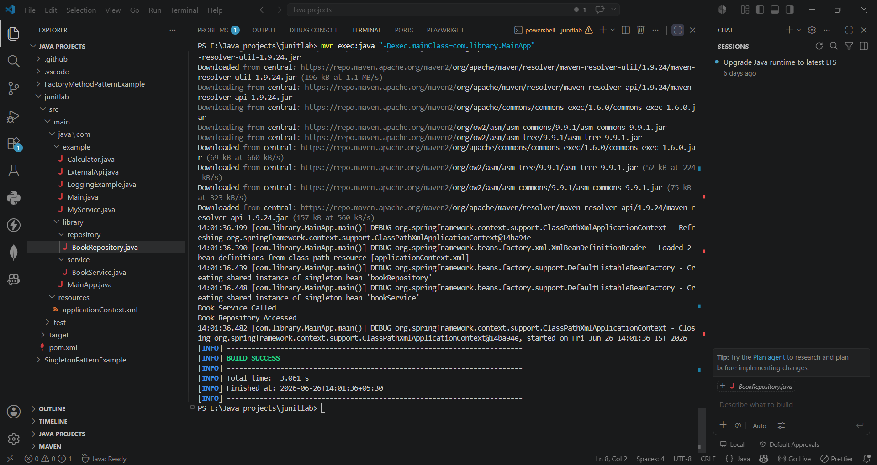

Exercise 2: Implementing Dependency Injection
Scenario:
In the library management application, you need to manage the dependencies between the BookService and BookRepository classes using Spring's IoC and DI.
Steps:
- Modify the XML Configuration:
  - Update applicationContext.xml to wire BookRepository into BookService.
- Update the BookService Class:
  - Ensure that BookService class has a setter method for BookRepository.
- Test the Configuration:
  - Run the LibraryManagementApplication main class to verify the dependency injection.
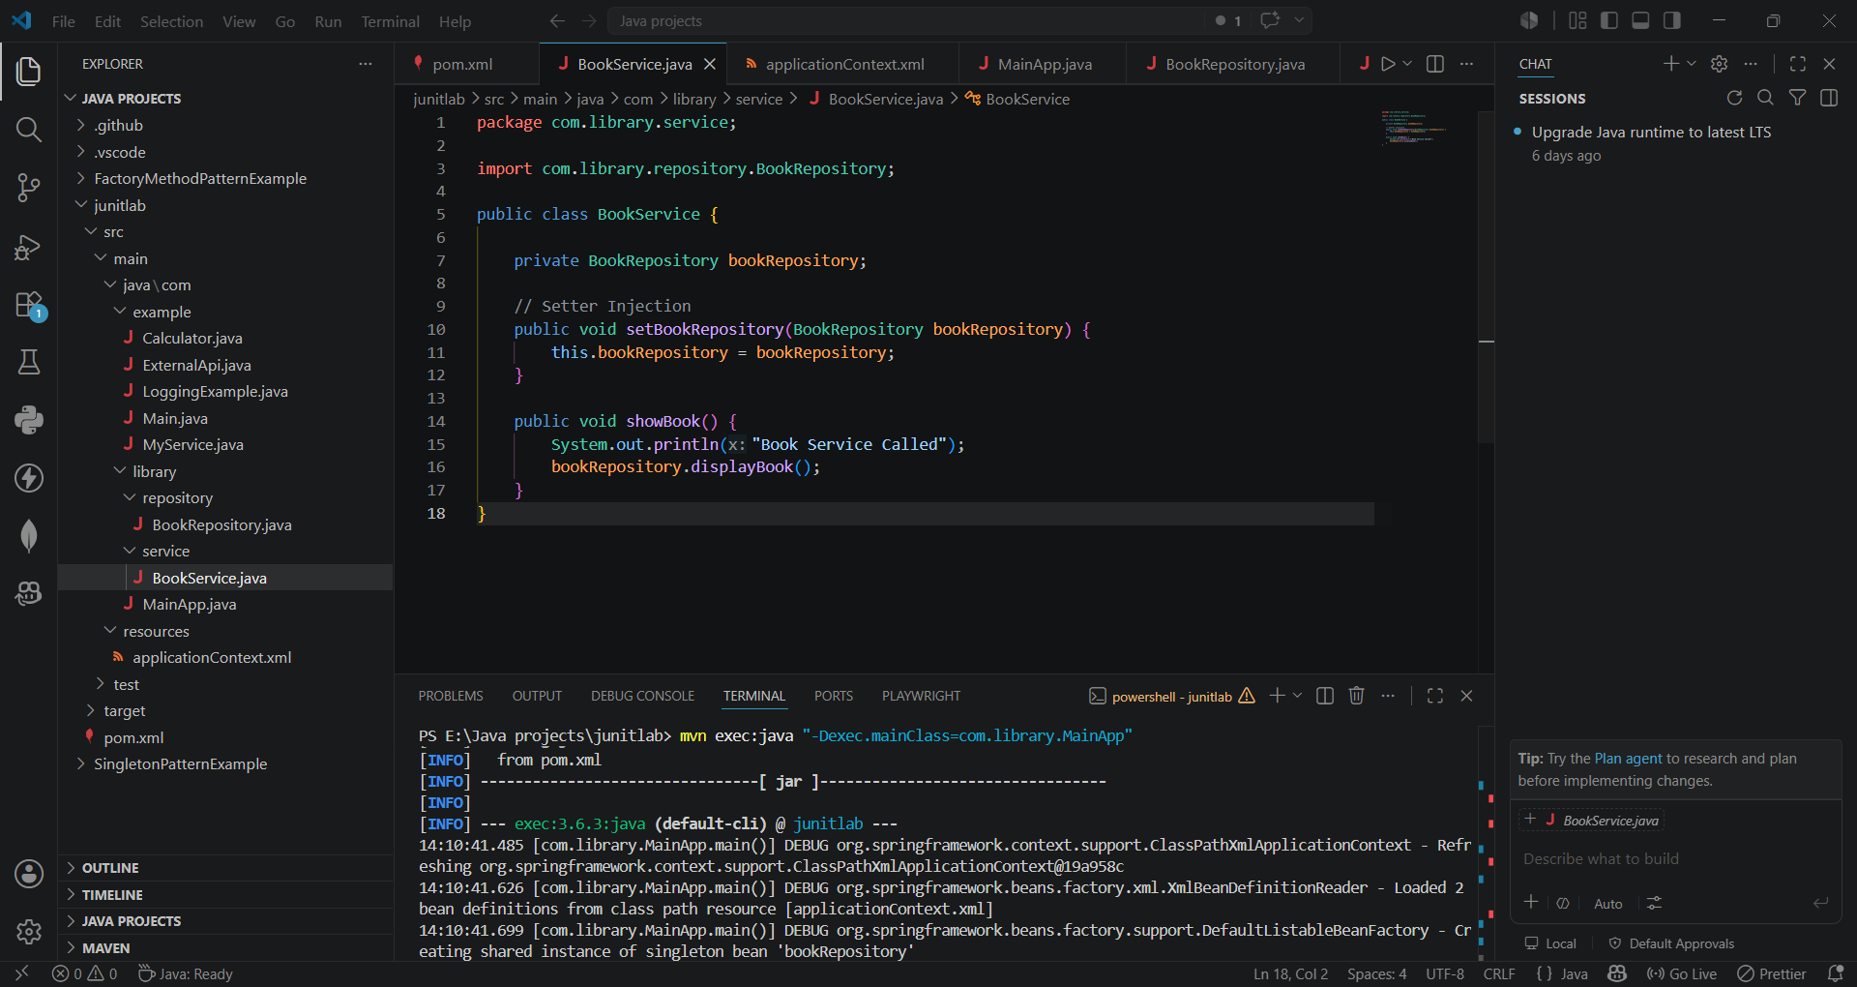

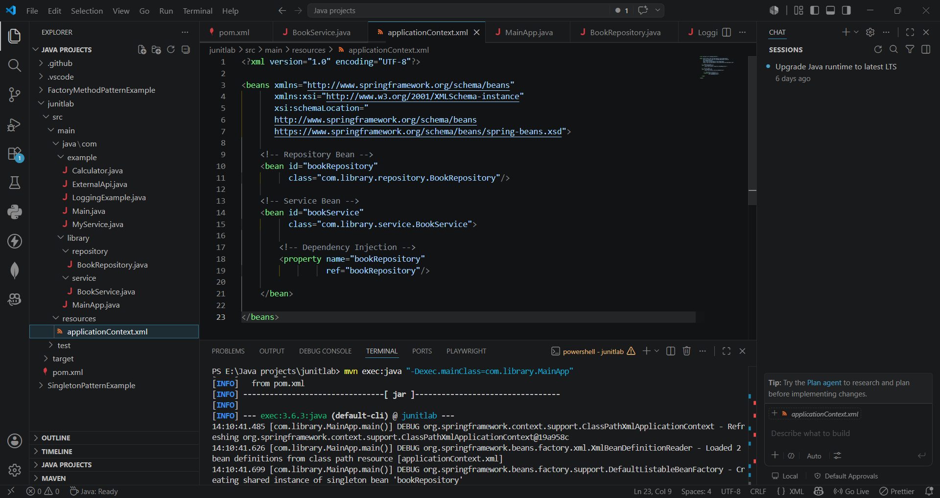
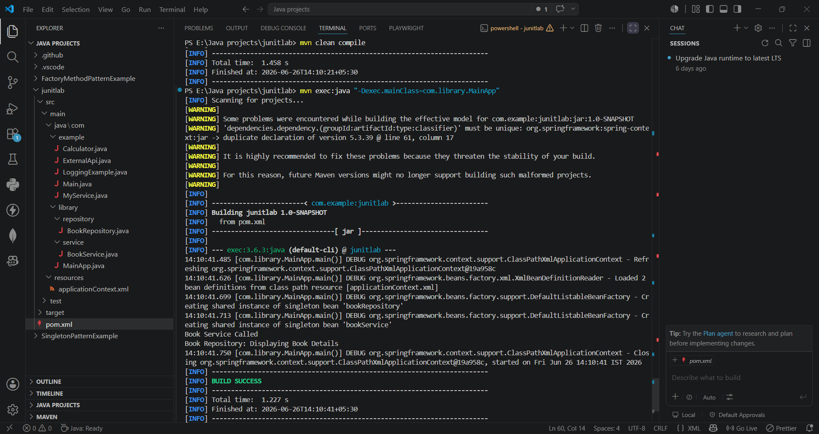

Exercise 4: Creating and Configuring a Maven Project
Scenario:
You need to set up a new Maven project for the library management application and add Spring dependencies.
Steps:
- Create a New Maven Project:
  - Create a new Maven project named LibraryManagement.
- Add Spring Dependencies in pom.xml:
  - Include dependencies for Spring Context, Spring AOP, and Spring WebMVC.
- Configure Maven Plugins:
Configure the Maven Compiler Plugin for Java version 1.8 in the pom.xml file
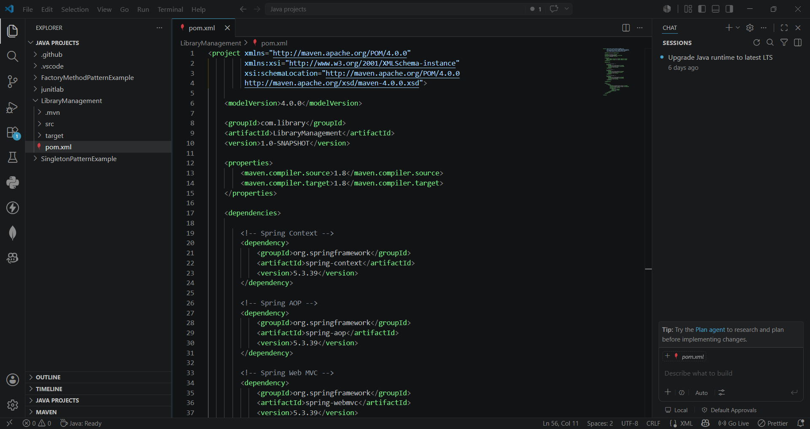

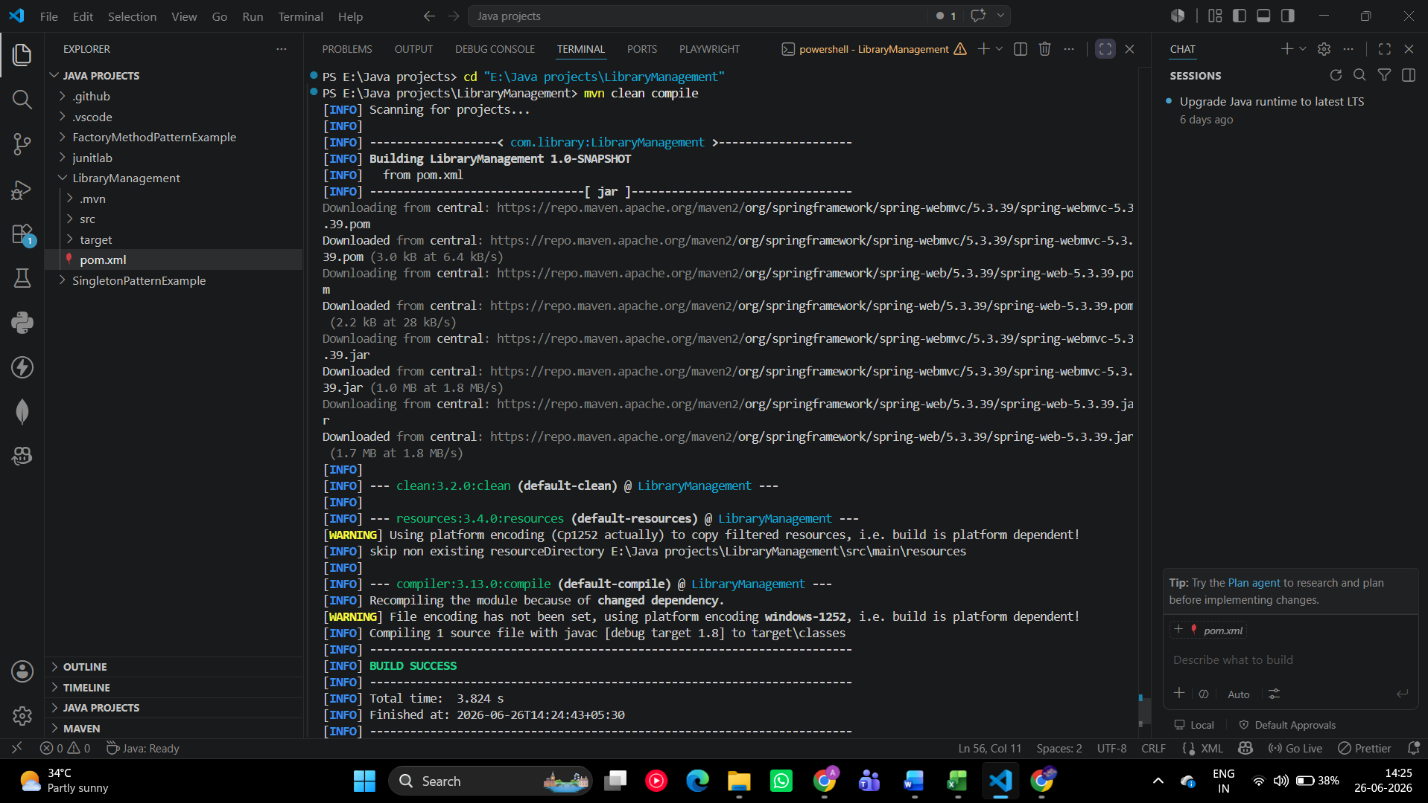

Hands on 1
Spring Data JPA - Quick Example
Software Pre-requisites
- MySQL Server 8.0
- MySQL Workbench 8
- Eclipse IDE for Enterprise Java Developers 2019-03 R
- Maven 3.6.2
Create a Eclipse Project using Spring Initializr
- Go to https://start.spring.io/
- Change Group as “com.cognizant”
- Change Artifact Id as “orm-learn”
- In Options > Description enter "Demo project for Spring Data JPA and Hibernate"
- Click on menu and select "Spring Boot DevTools", "Spring Data JPA" and "MySQL Driver"
- Click Generate and download the project as zip
- Extract the zip in root folder to Eclipse Workspace
- Import the project in Eclipse "File > Import > Maven > Existing Maven Projects > Click Browse and select extracted folder > Finish"
- Create a new schema "ormlearn" in MySQL database. Execute the following commands to open MySQL client and create schema.
> mysql -u root -p

mysql> create schema ormlearn;
- In orm-learn Eclipse project, open src/main/resources/application.properties and include the below database and log configuration.
# Spring Framework and application log
logging.level.org.springframework=info
logging.level.com.cognizant=debug

# Hibernate logs for displaying executed SQL, input and output
logging.level.org.hibernate.SQL=trace
logging.level.org.hibernate.type.descriptor.sql=trace

# Log pattern
logging.pattern.console=%d{dd-MM-yy} %d{HH:mm:ss.SSS} %-20.20thread %5p %-25.25logger{25} %25M %4L %m%n

# Database configuration
spring.datasource.driver-class-name=com.mysql.cj.jdbc.Driver
spring.datasource.url=jdbc:mysql://localhost:3306/ormlearn
spring.datasource.username=root
spring.datasource.password=root

# Hibernate configuration
spring.jpa.hibernate.ddl-auto=validate
spring.jpa.properties.hibernate.dialect=org.hibernate.dialect.MySQL5Dialect
- Build the project using ‘mvn clean package -Dhttp.proxyHost=proxy.cognizant.com -Dhttp.proxyPort=6050 -Dhttps.proxyHost=proxy.cognizant.com -Dhttps.proxyPort=6050 -Dhttp.proxyUser=123456’ command in command line
- Include logs for verifying if main() method is called.
import org.slf4j.Logger;
import org.slf4j.LoggerFactory;

private static final Logger LOGGER = LoggerFactory.getLogger(OrmLearnApplication.class);

public static void main(String[] args) {
SpringApplication.run(OrmLearnApplication.class, args);
LOGGER.info("Inside main");
}
- Execute the OrmLearnApplication and check in log if main method is called.
SME to walk through the following aspects related to the project created:
- src/main/java - Folder with application code
- src/main/resources - Folder for application configuration
- src/test/java - Folder with code for testing the application
- OrmLearnApplication.java - Walkthrough the main() method.
- Purpose of @SpringBootApplication annotation
- pom.xml
  - Walkthrough all the configuration defined in XML file
  - Open 'Dependency Hierarchy' and show the dependency tree.
Country table creation
- Create a new table country with columns for code and name. For sample, let us insert one country with values 'IN' and 'India' in this table.
create table country(co_code varchar(2) primary key, co_name varchar(50));
- Insert couple of records into the table
insert into country values ('IN', 'India');
insert into country values ('US', 'United States of America');
Persistence Class - com.cognizant.orm-learn.model.Country
- Open Eclipse with orm-learn project
- Create new package com.cognizant.orm-learn.model
- Create Country.java, then generate getters, setters and toString() methods.
- Include @Entity and @Table at class level
- Include @Column annotations in each getter method specifying the column name.
import javax.persistence.Column;
import javax.persistence.Entity;
import javax.persistence.Id;
import javax.persistence.Table;

@Entity
@Table(name="country")
public class Country {

@Id
@Column(name="code")
private String code;

@Column(name="name")
private String name;

// getters and setters

// toString()

}
Notes:
- @Entity is an indicator to Spring Data JPA that it is an entity class for the application
- @Table helps in defining the mapping database table
- @Id helps is defining the primary key
- @Column helps in defining the mapping table column
Repository Class - com.cognizant.orm-learn.CountryRepository
- Create new package com.cognizant.orm-learn.repository
- Create new interface named CountryRepository that extends JpaRepository<Country, String>
- Define @Repository annotation at class level
import org.springframework.data.jpa.repository.JpaRepository;
import org.springframework.stereotype.Repository;

import com.cognizant.ormlearn.model.Country;

@Repository
public interface CountryRepository extends JpaRepository<Country, String> {

}
Service Class - com.cognizant.orm-learn.service.CountryService
- Create new package com.cognizant.orm-learn.service
- Create new class CountryService
- Include @Service annotation at class level
- Autowire CountryRepository in CountryService
- Include new method getAllCountries() method that returns a list of countries.
- Include @Transactional annotation for this method
- In getAllCountries() method invoke countryRepository.findAll() method and return the result
Testing in OrmLearnApplication.java
- Include a static reference to CountryService in OrmLearnApplication class
private static CountryService countryService;
- Define a test method to get all countries from service.
private static void testGetAllCountries() {
LOGGER.info("Start");
List<Country> countries = countryService.getAllCountries();
LOGGER.debug("countries={}", countries);
LOGGER.info("End");
}
- Modify SpringApplication.run() invocation to set the application context and the CountryService reference from the application context.
ApplicationContext context = SpringApplication.run(OrmLearnApplication.class, args);
countryService = context.getBean(CountryService.class);

testGetAllCountries();
- Execute main method to check if data from ormlearn database is retrieved.

